**Final Project Report**

**Quiz of intelligence**



**Project Supervisor**

Hafiz Muhammad Azeem Sarwar

**Submitted By**

**F190235AE7**

Jawad Ali bc160401965

**Software Projects & Research Section,**

**Department of Computer Sciences,**

**Virtual University of Pakistan**

|  |
| --- |
|  |



**CERTIFICATE**

This is to certify that Jawad Ali (bc160401965) has worked on and completed their Software Project at Software & Research Projects Section, Department of Computer Sciences, Virtual University of Pakistan in partial fulfillment of the requirement for the degree of BS in Computer Sciences under my guidance and supervision.

In our opinion, it is satisfactory and up to the mark and therefore fulfills the requirements of BS in Computer Sciences.

**Supervisor / Internal Examiner**

Hafiz Muhammad Azeem Sarwar

Supervisor,

Software Projects & Research Section,

Department of Computer Sciences

Virtual University of Pakistan

___________________

(Signature)

**External Examiner/Subject Specialist**

<<External Supervisor Name>>

___________________

(Signature)

**Accepted By:**

**_____________**

(For office use)

**EXORDIUM**

**In the name of Allah, the Compassionate, the Merciful.**

**Praise be to Allah, Lord of Creation,**

**The Compassionate, the Merciful,**

**King of Judgment-day!**

**You alone we worship, and to You alone we pray for help,**

**Guide us to the straight path**

**The path of those who You have favored,**

**Not of those who have incurred Your wrath,**

**Nor of those who have gone astray.**

**DEDICATION**

First of all I would like to thanks **Almighty Allah** who helped me in my every step of life and completing this project.

Then

I wholeheartedly dedicate to my beloved

**Parents**

Who taught me to trust in Allah and believe in hard work, who have been my source of inspiration and gave me strength when I thought of giving up, who continually provide their moral, spiritual, emotional and financial support.

**Teachers**

Who really worked hard on me to make the person I am today.

**ACKNOWLEDGEMENT**

All praise to Almighty Allah, and respect for His beloved Prophet (Peace Be Upon Him) who made us recognize our creator. I have great gratitude for the most Beneficent and Merciful Allah who always helped me in all matters of my life. He always rewarded me more than I deserve. I praise Allah Almighty for giving me the courage and strength to complete this project. All esteems are for His Prophet (Peace Be Upon Him) whose teachings have served as beacon light for the humanity in the hours of despair and provide us regular guidance in every sphere of life.

For the completion of my project many persons directly or indirectly assisted me. I am also thankful to my VU fellows who provide me a friendly environment through which I learnt a lot. I am also thankful to sir Hafiz Muhammad Azeem Sarwar for his guidance.

This project gave me chance to enhance my knowledge, skills and practical experience. I am grateful to my family members, who have provided me through moral and emotional support in my life. I am also grateful to my cuisine who have supported me along the way.

**PREFACE**

University gave list of various projects to choose. Moreover we were open to purpose our own project as well. So I sent proposal to make a quiz game in Unity game engine which was accepted.

In this era of technology, there has been many modes of learning. Students can learn anything anytime at their doorstep via internet. This game is also developed for educational purposes. Instead of wasting their free time in useless activities, students can learn a lot in an entertaining way.

Quiz of intelligence is a multiple choice questions (MCQs) based game. Quiz will not only increase the IQ level of user but also examine who is more intelligent among us.

Quiz will have different categories/topics from which user can select according to his choice to get quiz of that particular category or he can get questions from all categories. Quiz will start with several MCQs. Each question’ll have four options and 20 seconds to answer. On every correct answer user will get 20 points. User will also coins based on time he answered correctly. If user answered correctly with in first five seconds he’ll get 4 coins, 3 coins for first ten seconds and so on. User can also challenge his facebook friends who have installed this application to check who is more genius.

Quiz will have 3 levels of difficulty which will increase based on users level of intelligence.

The duration of this project is one year and I successfully completed my project in given span.

**TABLE OF CONTENTS**

|  |
| --- |
|  |

CHAPTER NO. 1

gathering & Analyzing info 10

1.1 Introduction

1.2 purpose

1.3 scope

1.4 definitions, acronyms and abbreviations

1.5 use cases and usage scenarios

1.5.1 Use Case Diagrams

1.5.2 Usage Scenarios

1.6 supplementary requirements

1.6.1 Usability

1.6.2 Reliability

1.6.3 Supportability

1.6.4 System Requirements

CHAPTER NO. 2

planning the project 11

2.1 Introduction

2.2 Methodology

* 1. Available Methodologies
  2. Chosen Methodology
  3. Reasons for Chosen Methodology
  4. Work Plan
  5. Project Structure
     1. Team Structure
     2. Project Schedule (Submission Calendar)

CHAPTER NO. 3

designing the project 12

3.1 Introduction

3.2 purpose

3.3 scope

* 1. definitions, acronyms and abbreviations
  2. Dynamic Model: Sequence Diagrams
  3. Object Model/Logical Model: Class Diagram
  4. Database Model (Database Diagram)
  5. Graphical User Interfaces

Chapter no.4

DEvelopment 13

4.1 Development plan (Architecture Diagram)

**CHAPTER 1**

Gathering & Analyzing Info

**1.1 Introduction**

Quiz of intelligence is a game developed with Unity game Engine to test users intelligence in an efficient manner. The main objective of quiz is instead of wasting free time in useless activities, user can play game to increase his knowledge without boring. Moreover he can challenge his friend to inspect who is more intelligent.

Every quiz will have seven MCQs question and user will get ten points and coins based on time he take to answer question on every correct answer. In difficult questions user can also take hint which will hide two wrong options. In multiplayer mode of quiz, user can challenge his friend. Both players will get same questions and at the end winner will be shown.

**1.2 Purpose**

This game is designed for educational purpose. It will help students to go beyond their normal curriculum and learn about various other aspects which are apart from the academic education e.g. sports, medical, music and many more. The basic intent to make this application is that instead of wasting free time on useless activities, user can increase his IQ level. User can also challenge his friends to inspect who has higher IQ level.

**1.3 Scope**

The system will consists of different categories from which user can select one to get questions from that particular category otherwise he’ll get questions from random categories. On every correct answer, user will get coins and points. Coins will be rewarded on basis of time taken to answer given question. In case user stuck on a question, he can take hint be investing coins. Moreover, he can challenge his friend to examine who is more intelligent.

Results screen will be shown after every questionnaire that will show name of users, time taken to solve the questionnaire and so on.

**1.4 Definitions, Acronyms and Abbreviations**

**Definitions**

GameObject:

Base class for all entities in Unity Scenes.

RectTransforms:

RectTransforms are used for GUI, to store and manipulate the position, size, and anchoring of a rectangle and supports various forms of scaling based on a parent RectTransform.

SerializeField:

Force Unity to serialize a private field.

Enumeration:

In C#, enum is a value type data type. The enum is used to declare a list of named integer constants

JSON:

JSON is a lightweight format for storing and transporting data

**Acronyms and Abbreviations**

OS Operating System

UI User Interface

MCQ Multiple Choice Question

SDK Software Development Kit

API Application Program Interface

FB Facebook

TMPro Text Mesh Pro

JSON JavaScript Object Notation

**1.5 Use cases and usage scenarios**

**1.5.1 Use Case Diagrams**

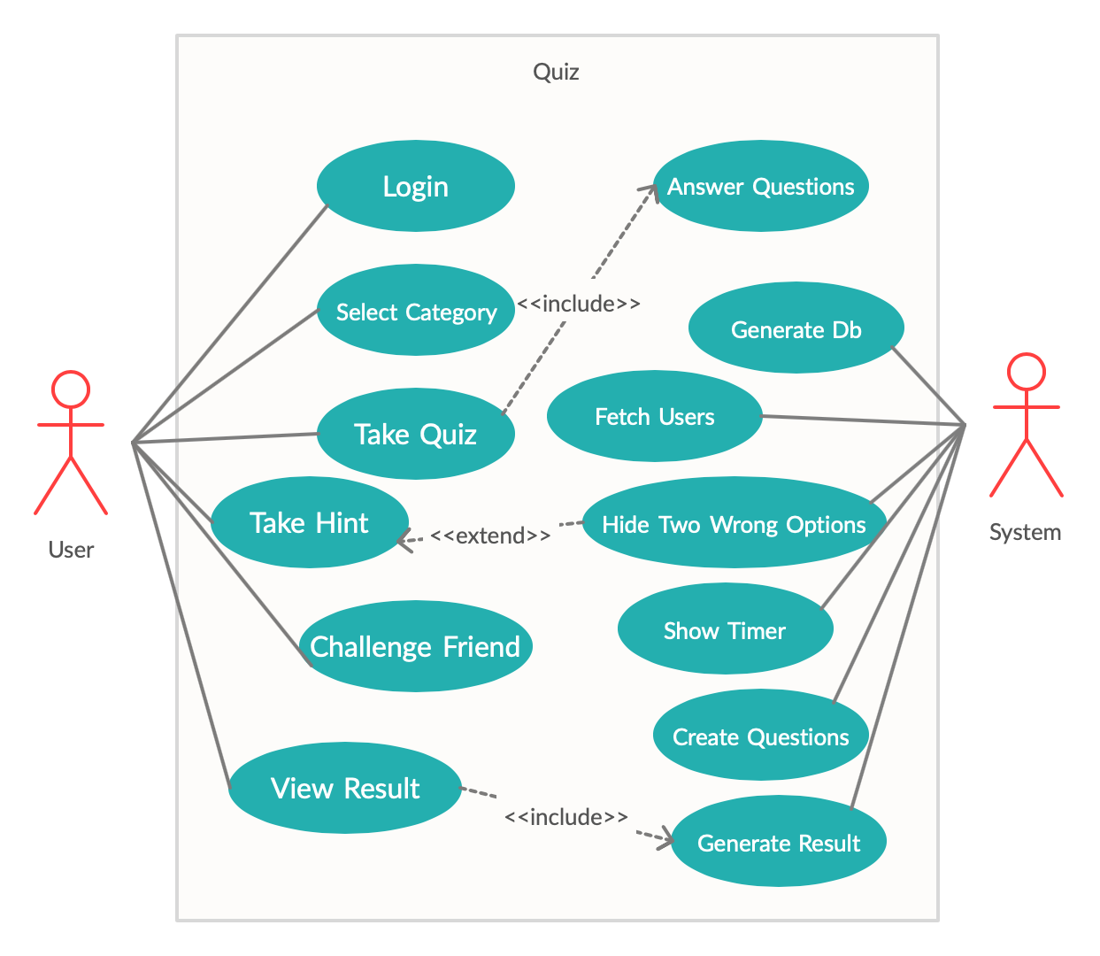

**1.5.2 Usage scenarios**

|  |  |
| --- | --- |
| **Use Case Title** | **Login** |
| Use Case Id | 001 |
| Actions | * Click on log in button * Select your facebook account * User’ll be logged in |
| Description | When user opens application, if he is not logged in already, show him login screen to log in. |
| Alternative Paths | Close the login pop up to quit application. |
| Pre Conditions | On start of application, if user is not logged in, show him login screen. |
| Post Conditions | User will login with facebook |
| Exception | Internet connection throw Exception |
| Author | **Jawad Ali** |

|  |  |
| --- | --- |
| **Use Case Title** | **Generate DB** |
| Use Case Id | 002 |
| Actions | * Generate local DB |
| Description | When application launched, create local db by fetching questions from server |
| Alternative Paths | Application will quit |
| Pre Conditions | Database has not created yet |
| Post Conditions | Local database created |
| Exception | Internet connection throw Exception |
| Author | **Jawad Ali** |

|  |  |
| --- | --- |
| **Use Case Title** | **Select Category** |
| Use Case Id | 003 |
| Actions | * Click on play button * Select a category |
| Description | When user clicks on play button, he’ll shown category screen from which he have to select a category to get question from. |
| Alternative Paths | Click on random categories button. Or click on back button to go back to main menu. |
| Pre Conditions | Click on play button |
| Post Conditions | System will fetch questions from that particular category. |
| Exception | Database is empty |
| Author | **Jawad Ali** |

|  |  |
| --- | --- |
| **Use Case Title** | **Create Questions** |
| Use Case Id | 004 |
| Actions | * Create question from db |
| Description | Create question from selected category and users difficulty level. |
| Alternative Paths | Game over |
| Pre Conditions | User should select category |
| Post Conditions | Question generated from that particular category and difficulty level. |
| Exception | Database is empty |
| Author | **Jawad Ali** |

|  |  |
| --- | --- |
| **Use Case Title** | **Take Quiz** |
| Use Case Id | 005 |
| Actions | * Click on one of four options buttons |
| Description | On start of quiz, user will get MCQs with four options. User have to select one option to answer. |
| Alternative Paths | Time passed i.e. its wrong answer |
| Pre Conditions | User should start quiz |
| Post Conditions | Answer will be verified. Either its correct or wrong. |
| Exception | Database is empty |
| Author | **Jawad Ali** |

|  |  |
| --- | --- |
| **Use Case Title** | **Show Timer** |
| Use Case Id | 006 |
| Actions | * Show time slider |
| Description | When a question loaded show time slider to keep user update to remaining time. |
| Alternative Paths | Question not loaded yet, don’t start timer |
| Pre Conditions | Question should loaded |
| Post Conditions | Timer starts when questions loaded |
| Exception | Database is empty |
| Author | **Jawad Ali** |

|  |  |
| --- | --- |
| **Use Case Title** | **Take Hint** |
| Use Case Id | 007 |
| Actions | * Click on hint button |
| Description | In difficult questions, user can take hint to hide two wrong options. |
| Alternative Paths | Wrong options will not hide |
| Pre Conditions | User should have suitable coins to take hint |
| Post Conditions | Two wrong options will hide |
| Exception | Database is empty |
| Author | **Jawad Ali** |

|  |  |
| --- | --- |
| **Use Case Title** | **Hide Two Wrong Options** |
| Use Case Id | 008 |
| Actions | * Hide two wrong options |
| Description | When user click on hint button hide two wrong options if he had enough coins. |
| Alternative Paths | Show him less coins error. |
| Pre Conditions | Click on hint button and have enough coins. |
| Post Conditions | Two wrong options hide |
| Exception | Database is empty |
| Author | **Jawad Ali** |

|  |  |
| --- | --- |
| **Use Case Title** | **Verify Answer** |
| Use Case Id | 009 |
| Actions | * Verify user’s answer |
| Description | When user click on one of the options, verify his answer against db. |
| Alternative Paths | Either answer is correct or wrong. |
| Pre Conditions | User should answer the question |
| Post Conditions | Score added if he answers correct. |
| Exception | Database is empty |
| Author | **Jawad Ali** |

|  |  |
| --- | --- |
| **Use Case Title** | **Fetch Users** |
| Use Case Id | 010 |
| Actions | * Fetch all user of application |
| Description | In multiplayer mode, show user list of all user |
| Alternative Paths | There is no user registered |
| Pre Conditions | User should login |
| Post Conditions | All players list will be created |
| Exception | Internet connection throw Exception |
| Author | **Jawad Ali** |

|  |  |
| --- | --- |
| **Use Case Title** | **Challenge Friend** |
| Use Case Id | 011 |
| Actions | * Click on challenge button in front of user name to invite him |
| Description | Challenge one of the users in the users list fetched from firebase server. |
| Alternative Paths | Play Single player game |
| Pre Conditions | Players list should be fetched |
| Post Conditions | Multiplayer game will start |
| Exception | Internet connection throw Exception |
| Author | **Jawad Ali** |

|  |  |
| --- | --- |
| **Use Case Title** | **Accept/Reject Challenge** |
| Use Case Id | 012 |
| Actions | * Click on Accept button * Click on Reject button |
| Description | When player A challenges other online player B, player B will get Invitation pop up. He can click on accept button to accept the challenge or click on reject button to reject the challenge. |
| Alternative Paths | Close the Invitation pop up |
| Pre Conditions | Payer should be online. |
| Post Conditions | Game starts if accepts the challenge and main menu loads if clicked on reject button |
| Exception | Internet connection throw Exception |
| Author | **Jawad Ali** |

|  |  |
| --- | --- |
| **Use Case Title** | **Generate Result** |
| Use Case Id | 013 |
| Actions | * Generate result of quiz |
| Description | Show user’s result at the end of questionnaire. Show winner incase of multiplayer game |
| Alternative Paths | Questionnaire is not completed. |
| Pre Conditions | User should complete quiz |
| Post Conditions | Result will be generated |
| Exception | No chance of Exception here |
| Author | **Jawad Ali** |

|  |  |
| --- | --- |
| **Use Case Title** | **View Result** |
| Use Case Id | 014 |
| Actions | * View result of quiz |
| Description | View the result generate for the quiz you just taken |
| Alternative Paths | Questionnaire is not completed. |
| Pre Conditions | User should complete quiz |
| Post Conditions | Result will be generated |
| Exception | No chance of Exception here |
| Author | **Jawad Ali** |

**1.6 Supplementary requirements**

**1.6.1 Usability**

Prioritize the important functions of the system based on usage pattern. Frequently used functions should be tested for usability, as should complex and critical functions. Be sure to create requirement for this.

**1.6.2 Reliability**

Users should trust the system even after using it for a long time. Create a requirement that data created in the system will be retained for a number of years without the data being changed by the system. It’s good idea to also include requirement that make it easier to monitor system performance.

**1.6.3 Supportability**

The system should be cost effective to maintain. Maintainability may cover diverse levels of documentation, such as system documentation, as well as test documentation for example, which test cases and test plans will accompany the system.

**1.6.4 System Requirements**

Requirements about resources required, response time, transaction rate, throughput, benchmark specifications or anything else having to do with performance.

**CHAPTER 2**

Planning the Project

**2.1 Introduction**

Quiz of intelligence is a game developed with Unity game Engine to test users intelligence in an efficient manner. The main objective of quiz is instead of wasting free time in useless activities, user can play game to increase his knowledge without boring. Moreover he can challenge his friend to inspect who is more intelligent.

Every quiz will have seven MCQs question and user will get ten points and coins based on time he take to answer question on every correct answer. In difficult questions user can also take hint which will hide two wrong options. In multiplayer mode of quiz, user can challenge his friend. Both players will get same questions and at the end winner will be shown.

**2.2 Methodology**

A methodology is codified set of practices that may be used to Software Engineering in collection of techniques, which are used to improve the quality of software product. Its the documented collection of policies, processes and procedures used by development team to improve Software Development Methodology (SDM) or System Development Life Cycle (SDLC). Software methodology reduces defects in software development and provides shorter delivery times and better Value. The software methodology is revising of how to guide through each phase of process model. Now a days, there are number of methodologies exists.

**2.3 Available Methodologies**

**Waterfall Model**

Waterfall approach was first SDLC Model to be used widely in Software Engineering to ensure success of the project. In "The Waterfall" approach, the whole process of software development is divided into separate phases. In this Waterfall model, typically, the outcome of one phase acts as the input for the next phase sequentially.

The following illustration is a representation of the different phases of the Waterfall Model.

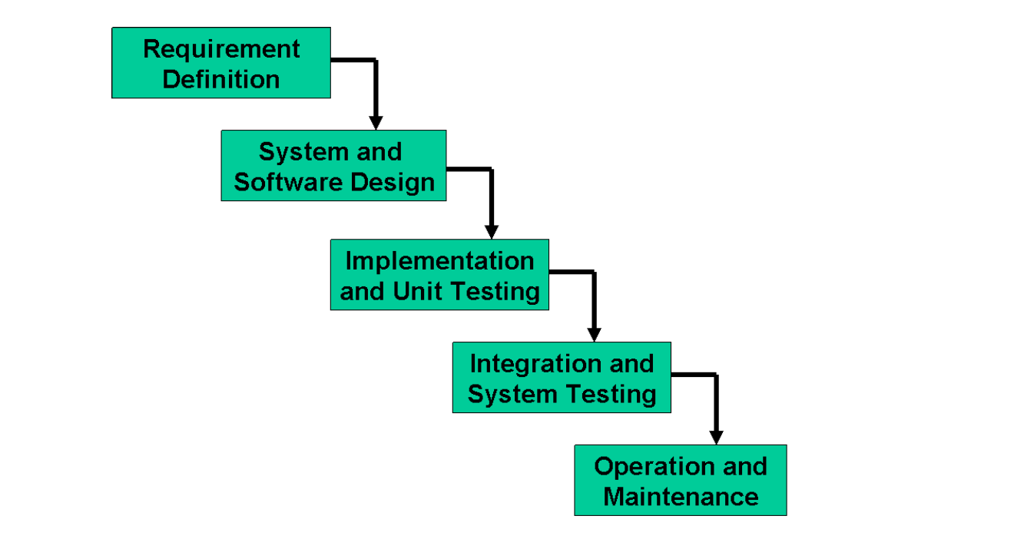

**Spiral Model**

The main idea of this model is to avert risk as there is always an element of risk in development of software. For example, key personnel may resign at a critical juncture, the manufacturer of the software development may go bankrupt, etc.

In its simplified form, the Spiral Model is Waterfall model plus risk analysis. In this case each stage is preceded by identification of alternatives and risk analysis and is then followed by evaluation and planning for the next phase. If risks cannot be resolved, project is immediately terminated. This is depicted in the following diagram.

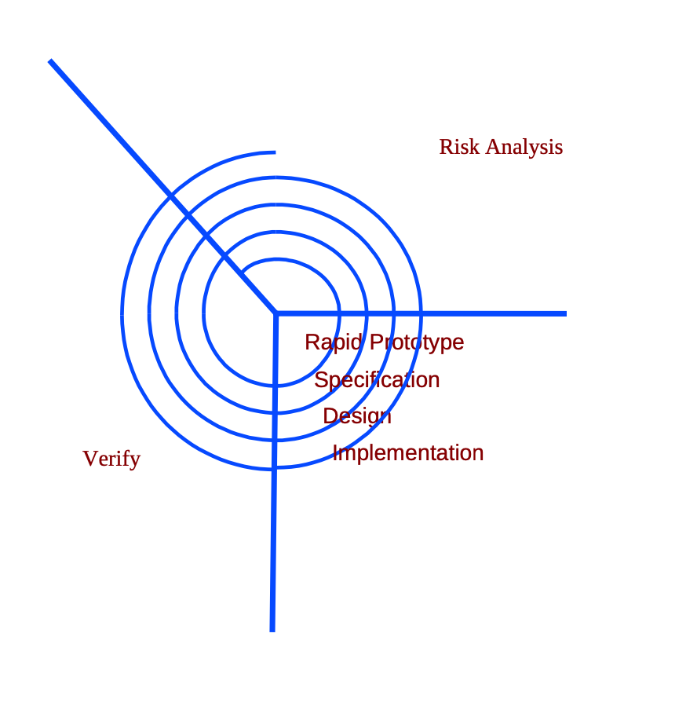

As can be seen, a Spiral Model has two dimensions. Radial dimension represents the cumulative cost to date and the angular dimension represents the progress through the spiral.

**2.4 Chosen Methodology**

The methodology chosen for this project is VU Process Model. The VU process model offers numerous for software developers thus because of its beneficial flow I used this methodology.

**VU Process Model**

We have used VU Process Model for this project. It is combination of Water fall and Spiral method. This model has defined starting and ending points. Development process is seen going downward like waterfall. In this model one phase is proceed to the next phase in sequence. A spiral model is divided into a number of framework activities, also called task regions. Typically, there are between three and six task regions. It minimizes the Risk.

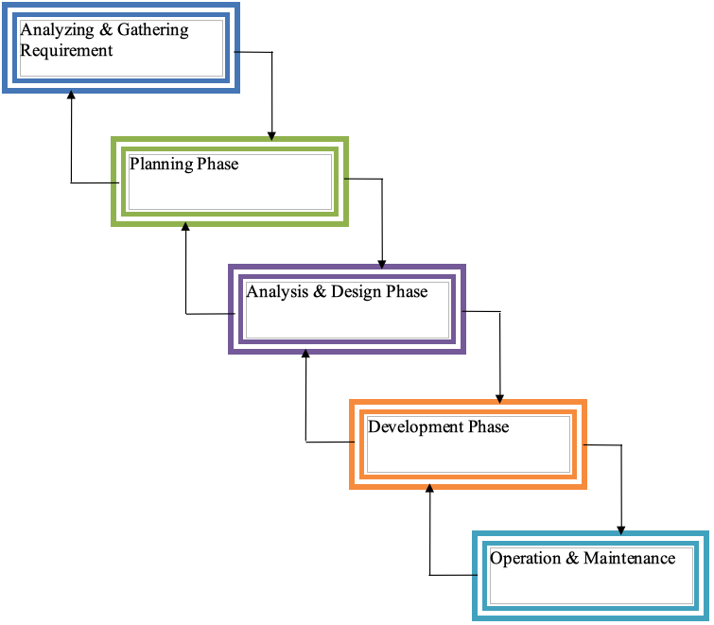

**2.5 Reasons For Chosen Methodology**

Some basic reasons for choosing this methodology are

* This model is very useful in both easy and critical software development.
* With the help of this model monitoring of software development is easy.
* Its processing is two way, if find any error in any phase it loop back to the previous phase.
* Its iterative in nature.

2.6 Work Plan

**2.7 Project Structure**

**2.7.1 Team Structure**

I worked on this project my own there is no partner hence no team.

**2.7.2 Project Schedule (Submission Calendar)**

Gantt Chart for project schedule is given below

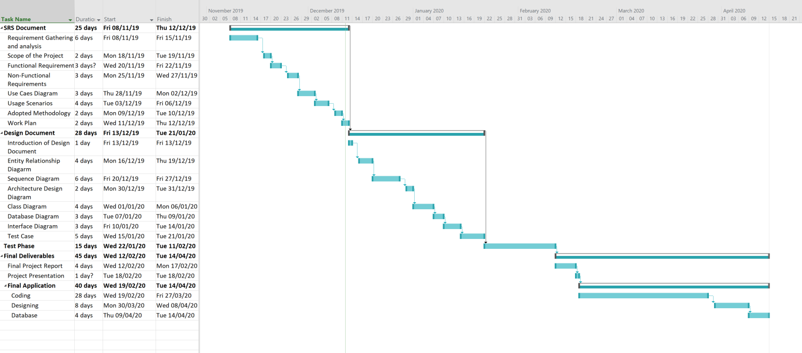

**CHAPTER 3**

Designing the Project

**3.1 Introduction**

Design document is a written description of software product, that a software designer writes in order to give a software development team overall guidance to the architecture of the software project. Practically, the description is required to coordinate a large team under a single vision, needs to be a stable reference, and outline all parts of the software and how they will work.

First stage in software development life cycle is SRS.

SRS document focuses on “what to do” whereas design document focuses on “how to do”. In the design phase the focus is shifted from ‘WHAT’ to ‘HOW’ means how the problem will be solved and which tools and techniques will be used. Design document maps the requirement gathered in SRS document into the components, their interfaces and behaviors. The purpose of design phase is to plan out a system that meets the requirement defined in SRS. In the design phase, the project team finds out the project solution that how the product will be created. To do this, the project team uses the inputs and tools to conduct the key activities, create the outputs, and meet the milestones for this Design phase.

Design document includes Entity Relation Diagram, Sequence Diagram. Architecture Diagram, Class diagram, Database Diagram and Interface Diagram and test cases. In this document we are going to create design document for “**Quiz of Intelligence**”.

**3.2 Purpose**

This game is designed for educational purpose. It will help students to go beyond their normal curriculum and learn about various other aspects which are apart from the academic education e.g. sports, medical, music and many more. The basic intent to make this application is that instead of wasting free time on useless activities, user can increase his IQ level. User can also challenge his friends to inspect who has higher IQ level.

**3.3 Scope**

The system will consists of different categories from which user can select one to get questions from that particular category otherwise he’ll get questions from random categories. On every correct answer, user will get coins and points. Coins will be rewarded on basis of time taken to answer given question. In case user stuck on a question, he can take hint be investing coins. Moreover, he can challenge his friend to examine who is more intelligent.

Results screen will be shown after every questionnaire that will show name of users, time taken to solve the questionnaire and so on.

**3.4 Definition, Acronyms and Abbreviations**

**Definition**

GameObject:

Base class for all entities in Unity Scenes.

RectTransforms:

RectTransforms are used for GUI, to store and manipulate the position, size, and anchoring of a rectangle and supports various forms of scaling based on a parent RectTransform.

SerializeField:

Force Unity to serialize a private field.

Enumeration:

In C#, enum is a value type data type. The enum is used to declare a list of named integer constants

JSON:

JSON is a lightweight format for storing and transporting data

**Acronyms and Abbreviations**

OS Operating System

UI User Interface

MCQ Multiple Choice Question

SDK Software Development Kit

API Application Program Interface

FB Facebook

TMPro Text Mesh Pro

JSON JavaScript Object Notation

**3.5 Dynamic Model: Sequence Diagram**

Sequence diagram is an interaction diagram that shows how objects operate with one another and in what order. Sequence diagrams are sometimes called event diagrams or event scenarios.

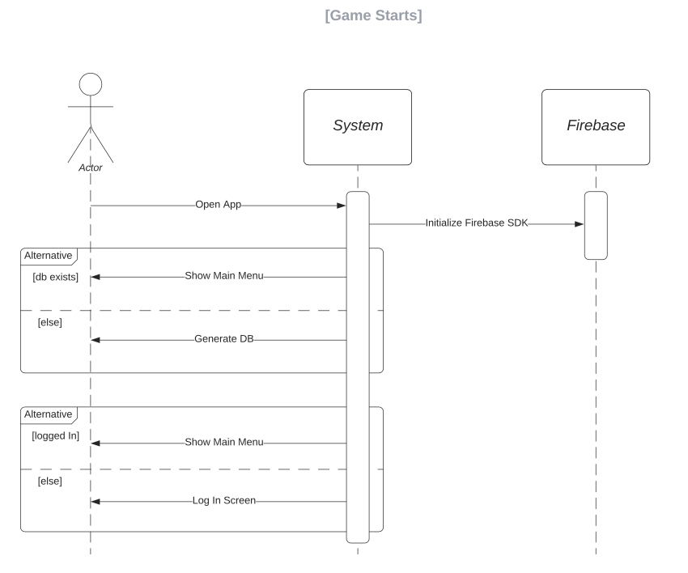

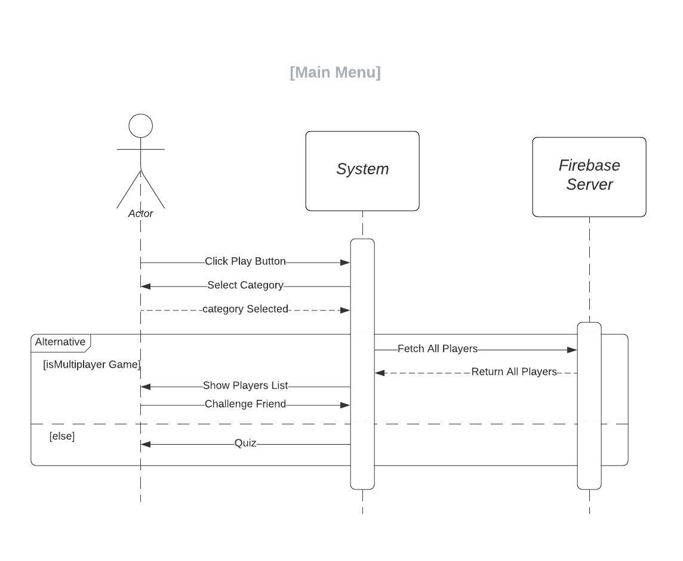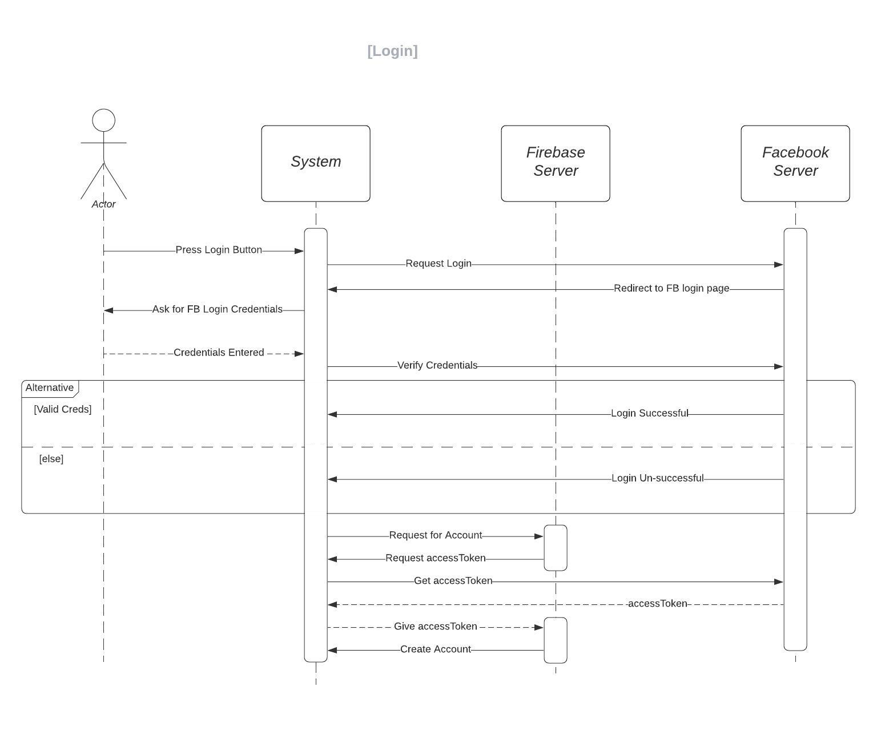

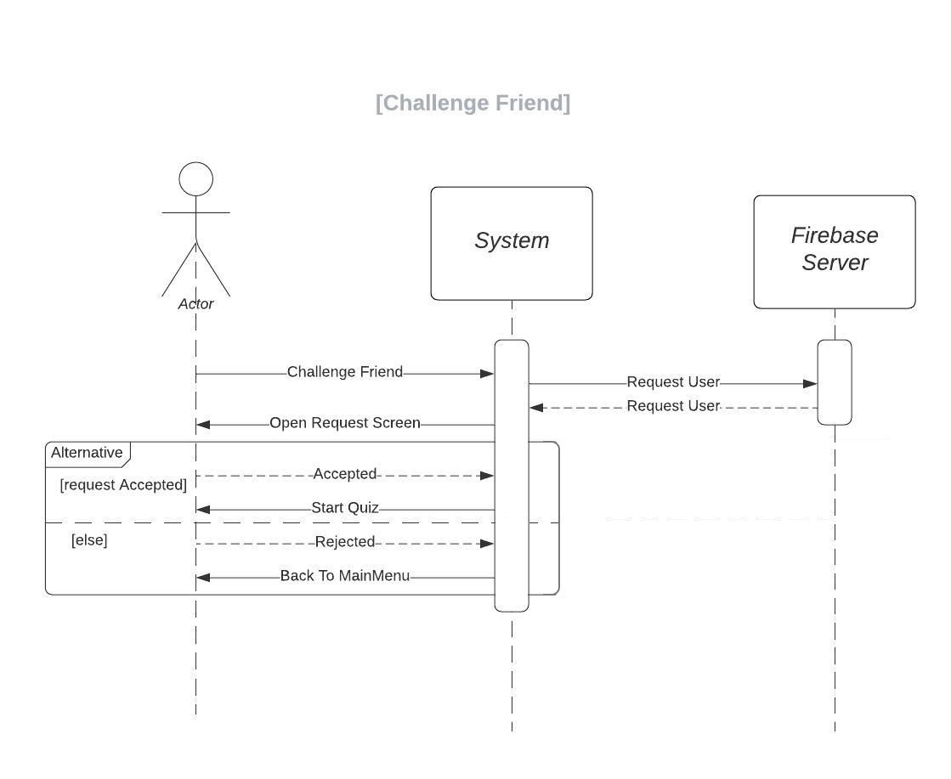

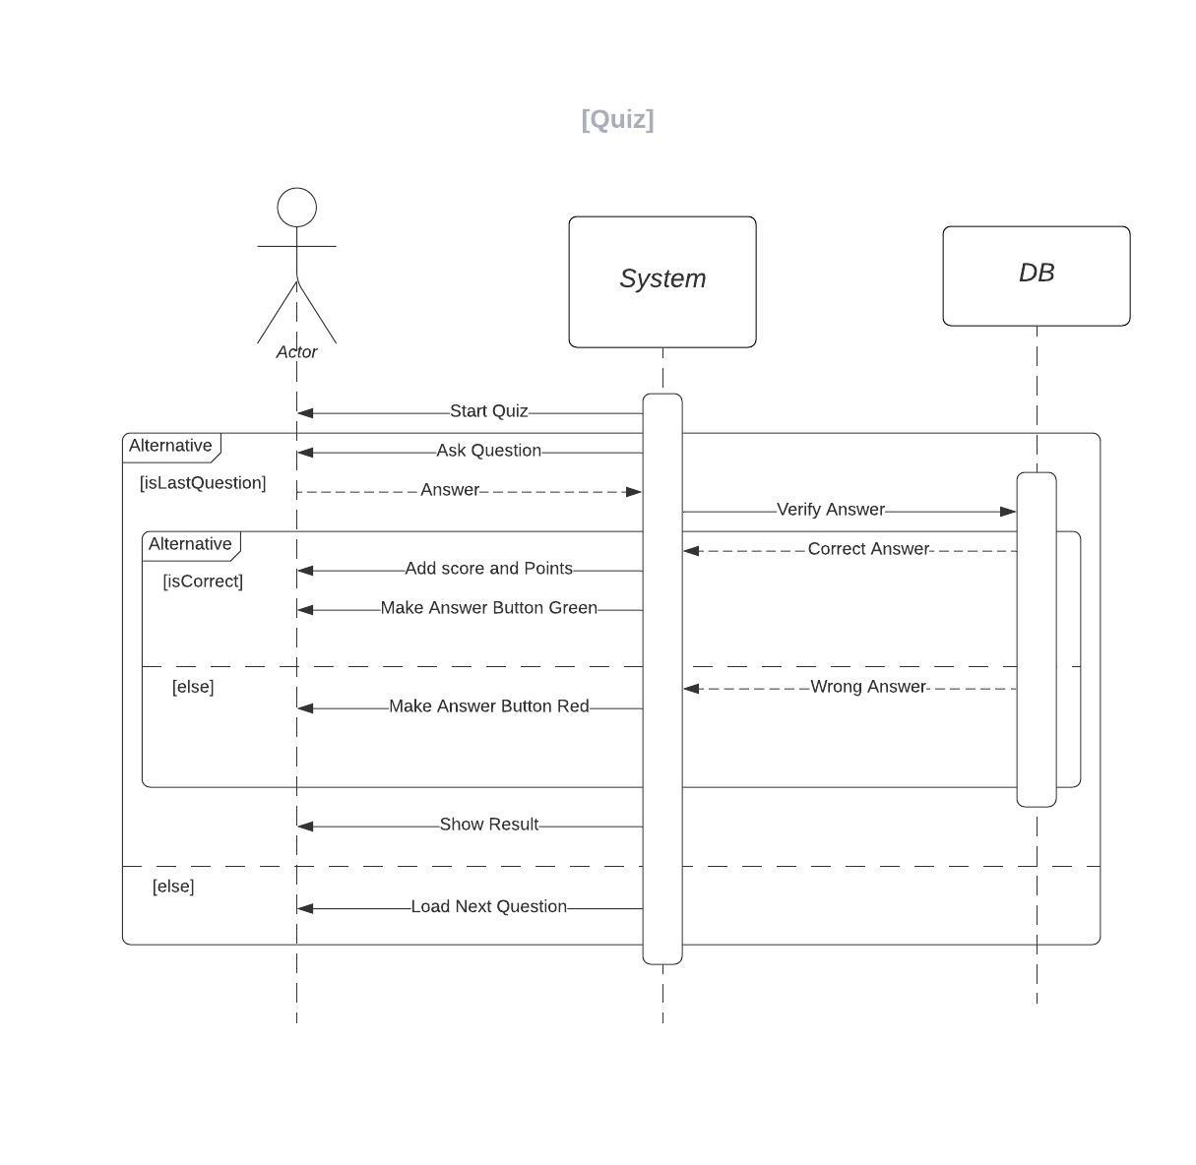

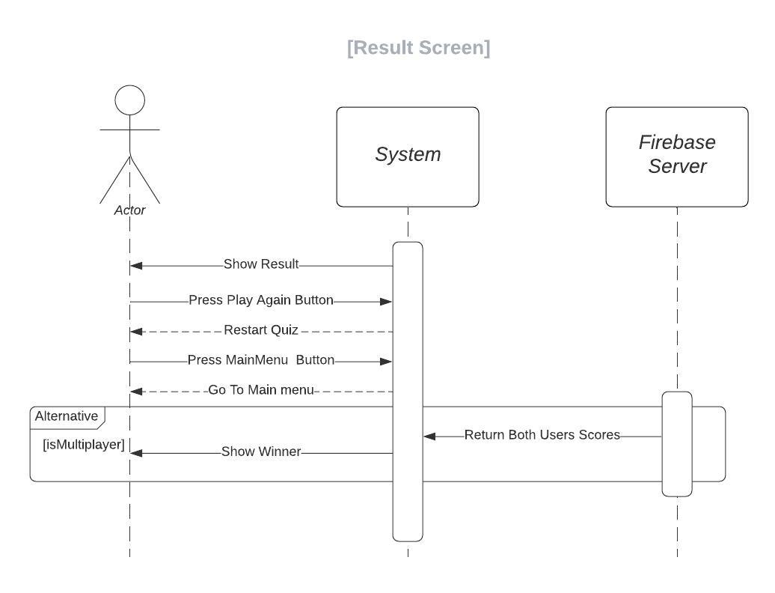

**3.6 Object Model / Logical Model: Class Diagram**

Class diagram is a type of static structure diagram that describes the structure of a system by showing the system's classes, their attributes, operations, and the relationships among objects.

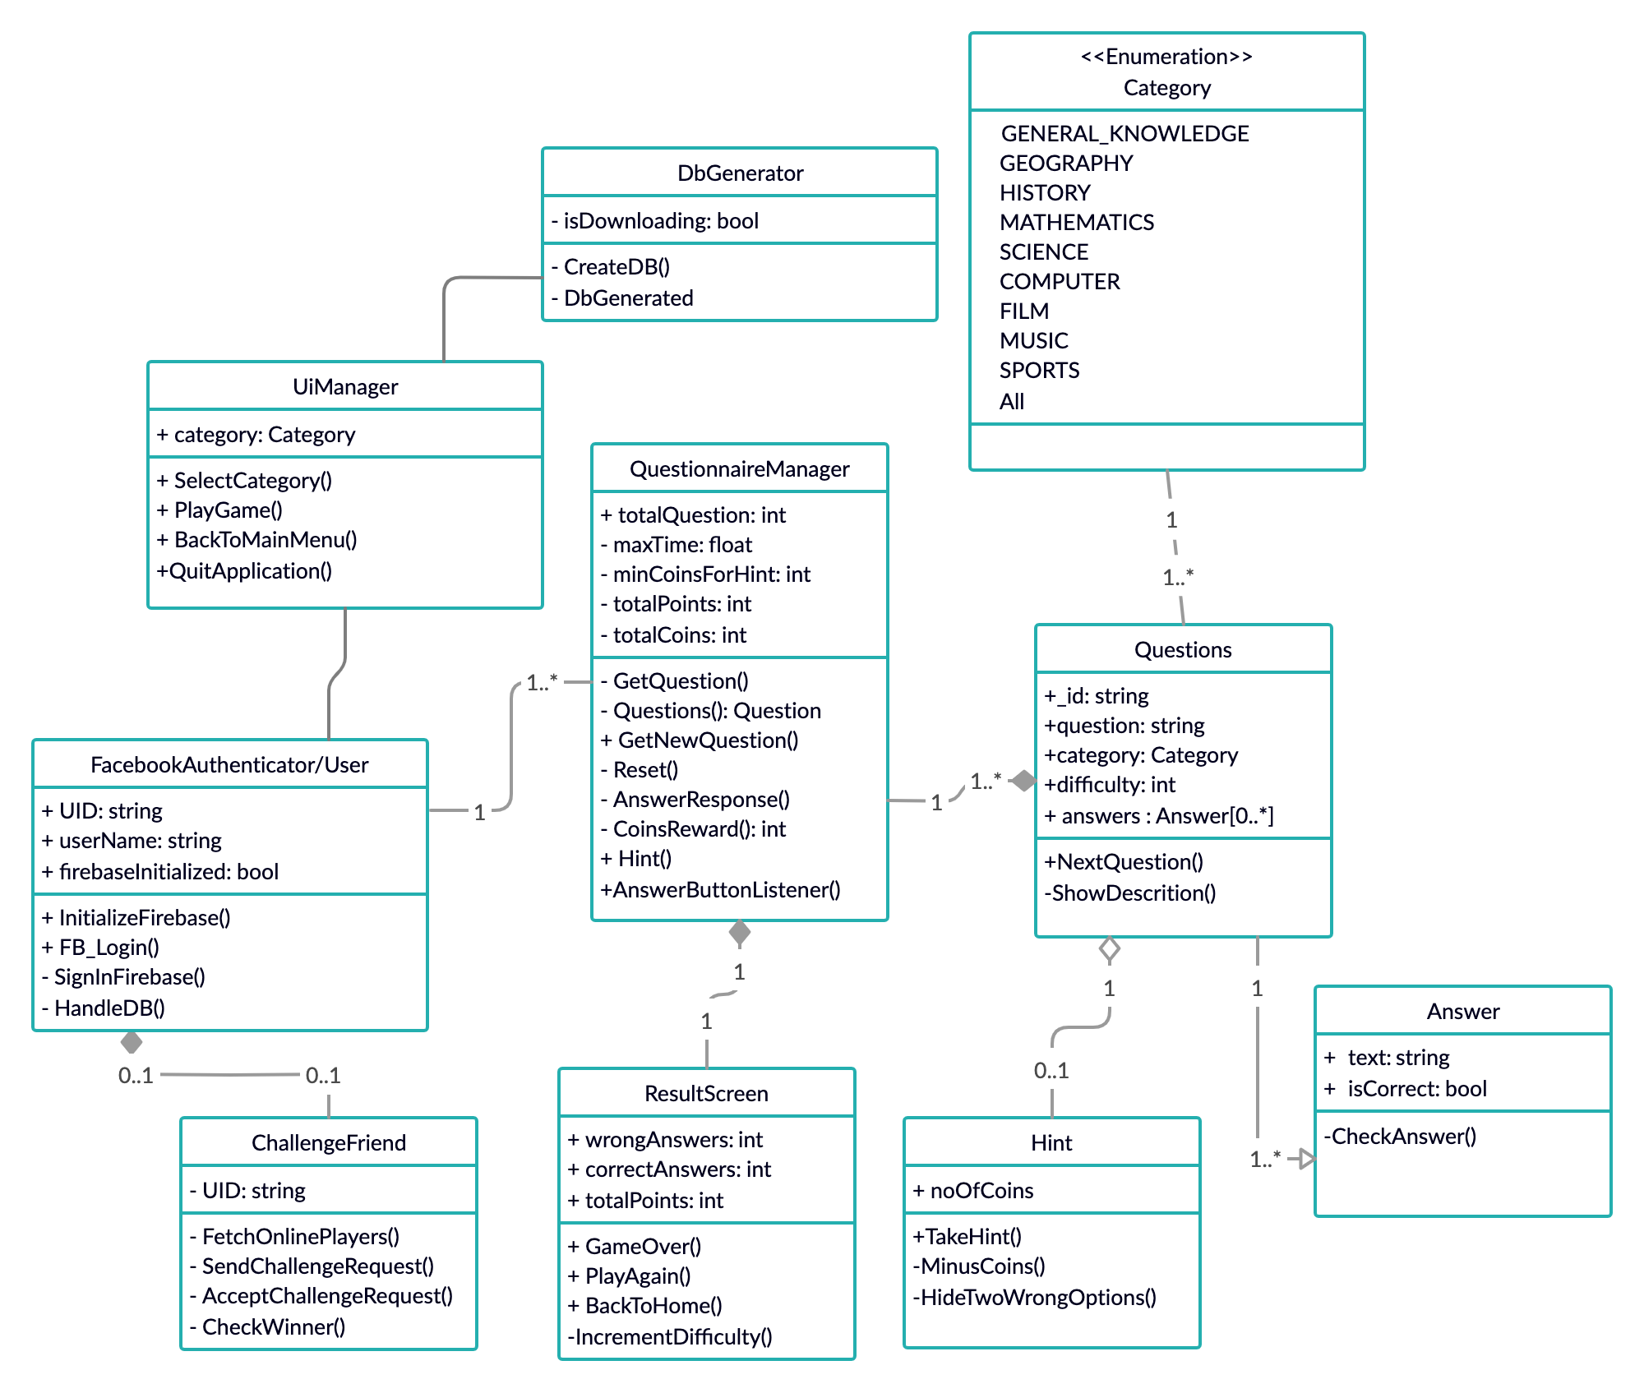

**3.7 Database Model (Database Diagram)**

Database design is the process of producing a detailed data model of a database. This logical data model contains all the needed logical and physical design choices and physical storage parameters needed to generate a design in a data definition language, which can then be used to create a database.

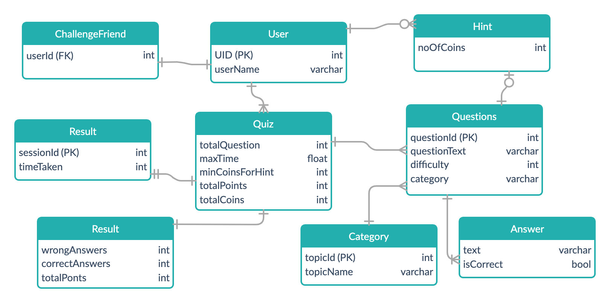

**3.8 Graphical User Interface**

The graphical user interface is a form of user interface that allows users to interact with electronic devices through graphical icons and audio indicator such as primary notation, instead of text-based user interfaces, typed command labels or text navigation.

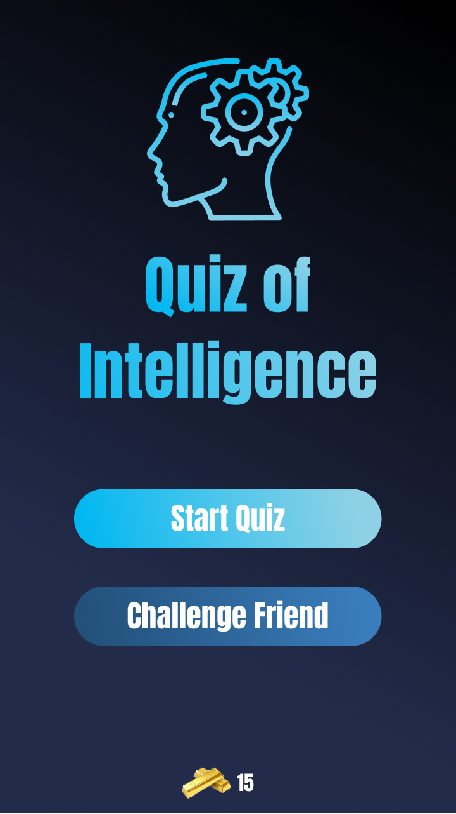

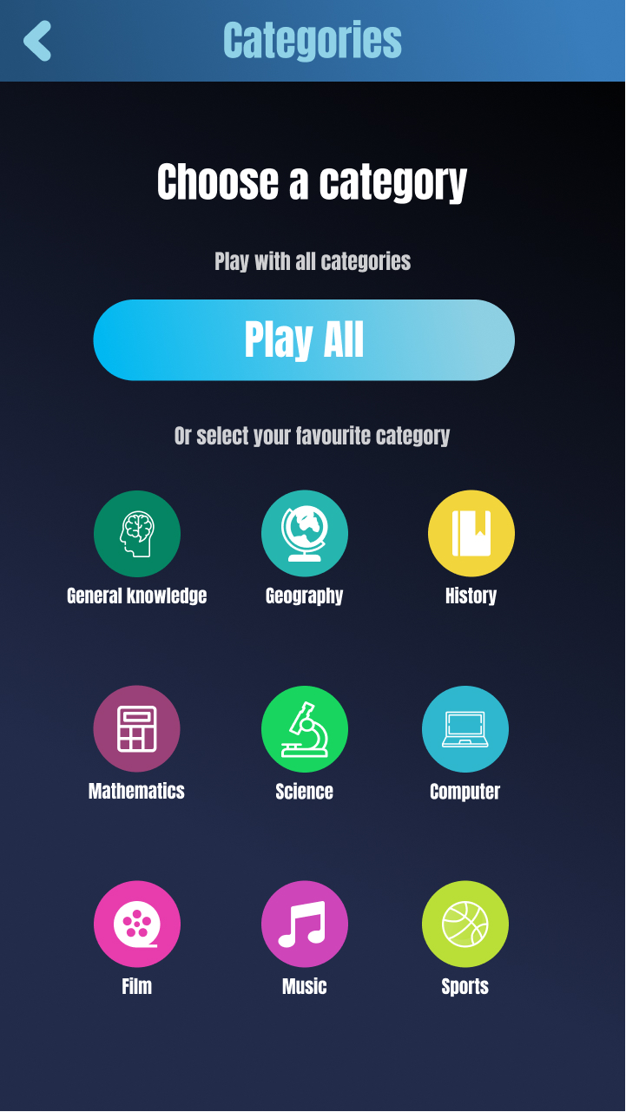

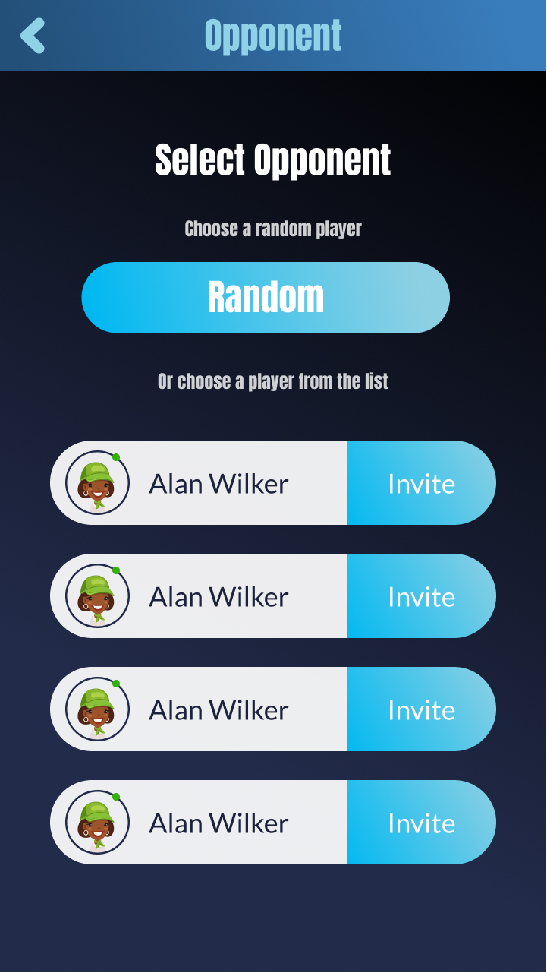

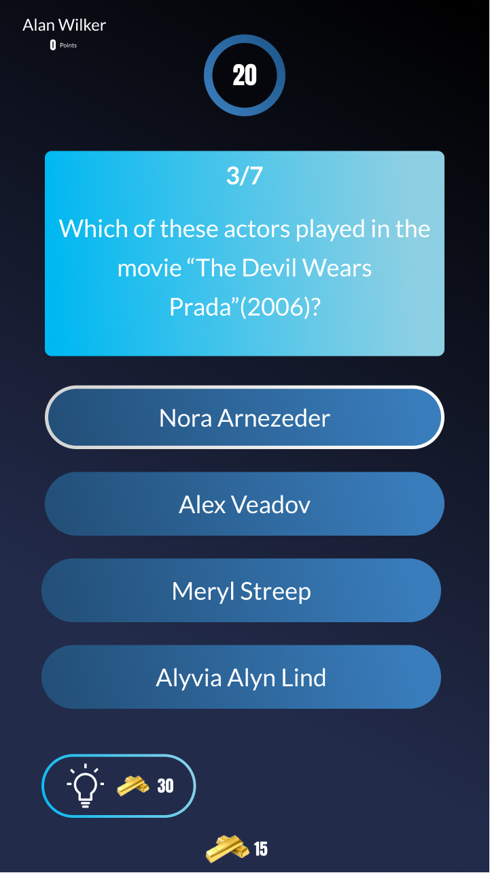

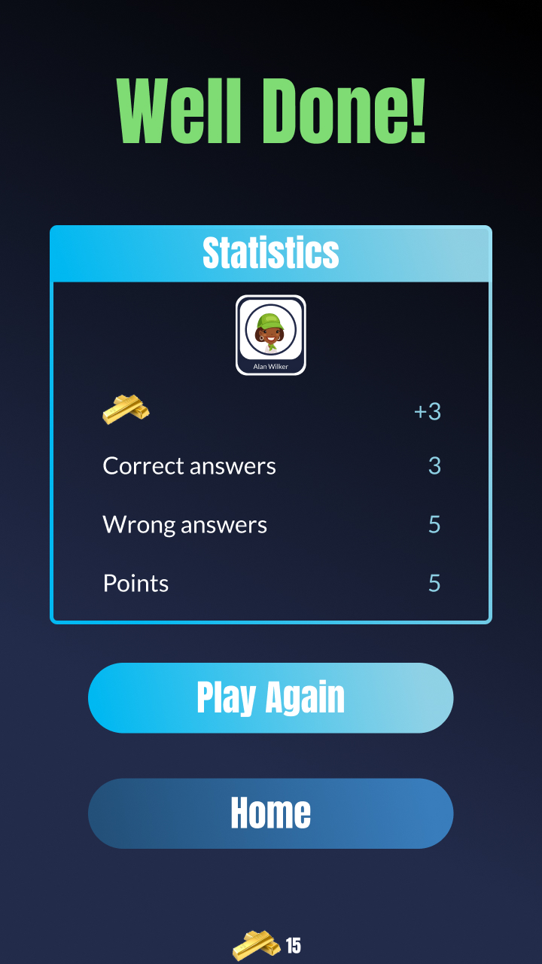

**CHAPTER 4**

Development

**4.1 Development plan (Architecture Diagram)**

Software Architecture Design is a crucial step for software and application developers to describe the basic software structure by separating functional areas into layers.

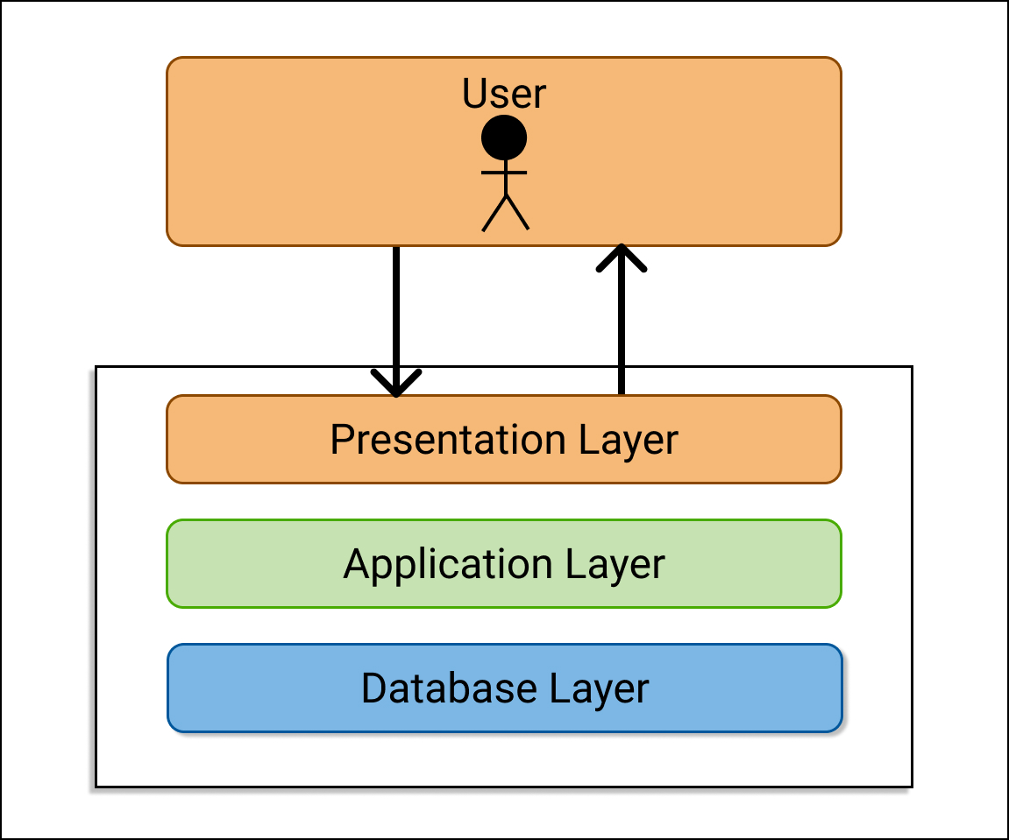

**REFERENCES**

* Facebook login <https://developers.facebook.com/docs/unity/getting-started/android>
* Firebase login <https://firebase.google.com/docs/auth/unity/facebook-login>
* Firebase realtime database <https://firebase.google.com/docs/database/unity/start>
* Firebase save data <https://firebase.google.com/docs/database/unity/save-data>
* Firebase retrieve data <https://firebase.google.com/docs/database/unity/retrieve-data>
* Dotween <http://dotween.demigiant.com/documentation.php>
* Unity UI <https://docs.unity3d.com/Manual/UIToolkits.html>
* C# Documentation <https://docs.microsoft.com/en-us/dotnet/csharp/tutorials/>

**APPENDIX**

|  |  |
| --- | --- |
| Chapter 1 | Gathering & Analyzing Info |
| Chapter 2 | Planning The Project |
| Chapter 3 | Designing The Project |
| Chapter 4 | Development |